EXPT NO:1 | Implementation of data charts
DATE: 06.01.2026 | Implementation of data charts

PRE-LAB QUESTIONS (PROVIDE BRIEF ANSWERS TO THE FOLLOWING QUESTIONS)

- How can visualization help an academic institution improve student outcomes?
Visualization converts large volumes of academic data into simple graphical formats that are easy to interpret. It helps institutions identify performance gaps across subjects and assessments. Faculty can quickly spot struggling students and low-scoring courses. Trends over time become visible through charts. This supports early intervention, personalized support, and continuous improvement in teaching methods.
- Which chart types are suitable for comparing subject-wise performance?
Bar charts are most suitable for comparing subject-wise academic performance. They clearly display differences in average marks across multiple subjects. Grouped bar charts allow comparison across different internal tests. These charts make it easy to identify difficult subjects. Hence, they are widely used in educational performance analysis.
- What type of data scale is used for student marks?
Student marks are measured using a ratio scale of data measurement. This scale includes a true zero point, indicating no marks scored. Equal intervals between values allow meaningful comparison. Mathematical operations such as addition and averaging are valid. Therefore, ratio-scale data supports accurate statistical and visual analysis.
- Why should raw academic data be cleaned before visualization?
Raw academic data may contain missing values, duplicate entries, or incorrect values. Data cleaning improves the accuracy and reliability of analysis. It ensures that visualizations correctly represent student performance. Unclean data can lead to misleading interpretations. Proper preprocessing results in meaningful and trustworthy insights.
- How does visualization support evidence-based decision making?
Visualization presents academic data in a clear and structured manner. Decision-makers can observe actual performance trends instead of relying on assumptions. It helps justify academic policies and teaching improvements using real data. Patterns and anomalies are easily identifiable. This leads to informed, transparent, and evidence-based decisions.

IN-LAB EXERCISE:
OBJECTIVE:
To design appropriate data charts to analyze and compare academic performance indicators.
SCENARIO:
An autonomous engineering college wants to analyze internal assessment performance of first-year students across five subjects to identify difficult courses and improve teaching strategies.
IN-LAB TASKS (Using R Language)
- Load required R libraries (ggplot2, dplyr)
- Import dataset using read.csv()
- Perform basic data preprocessing
- Create bar chart for subject-wise average marks
- Generate line chart for performance trend across tests
- Plot pie chart for grade distribution

(CODE: CONATAINS STUDENT ROLL NOS
SCREENSHOT OF CODE
SCREENSHOT OF OUTPUT)

Code:

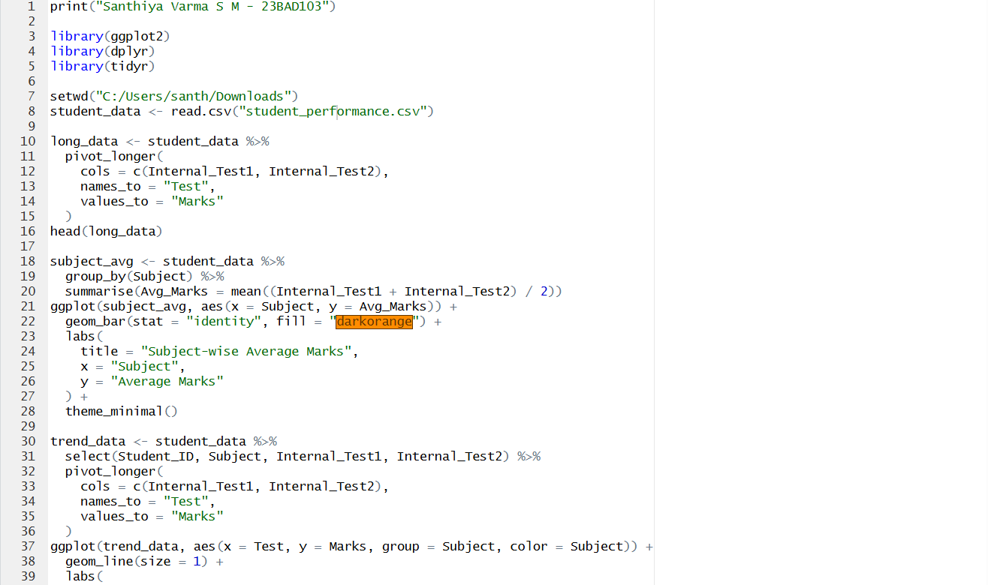
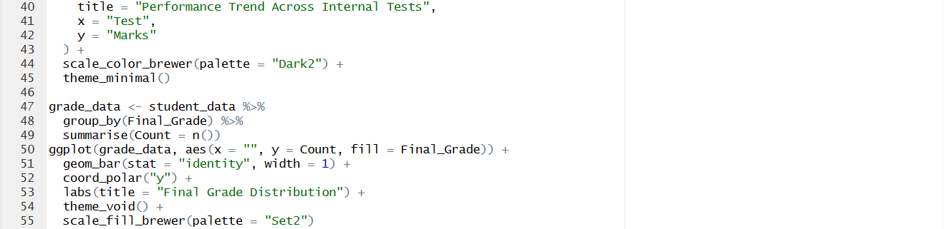

Output:

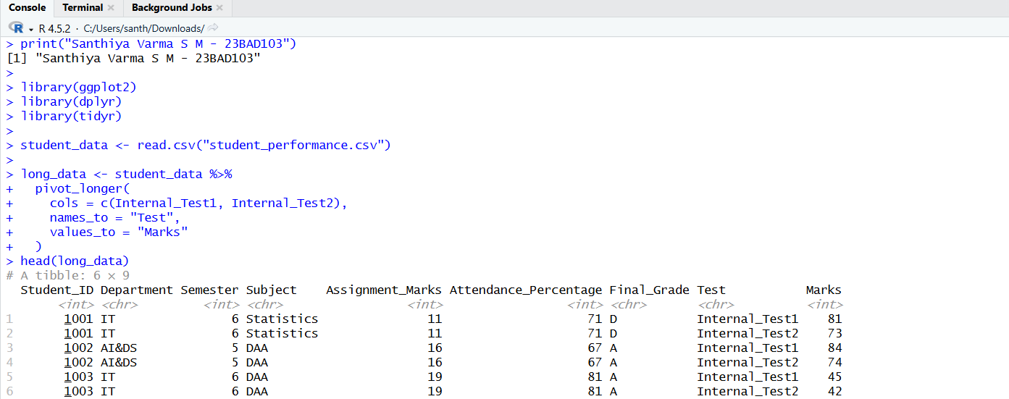

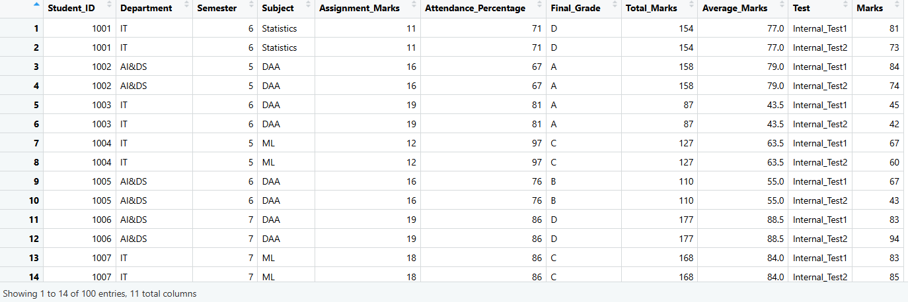
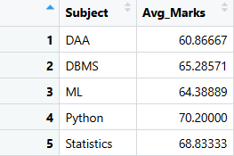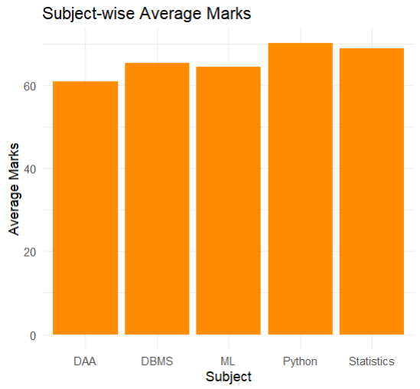

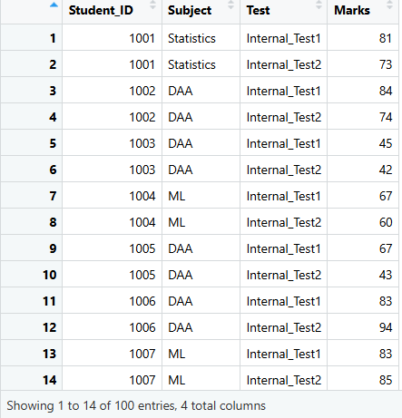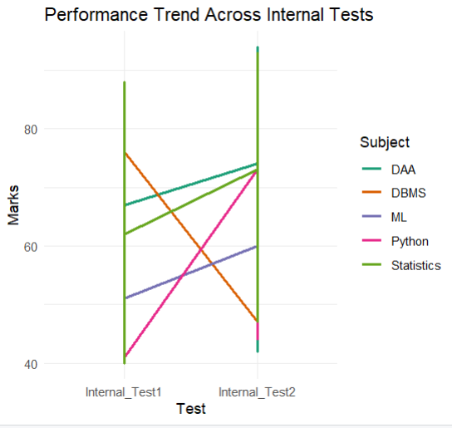

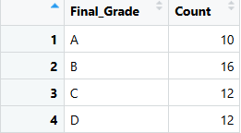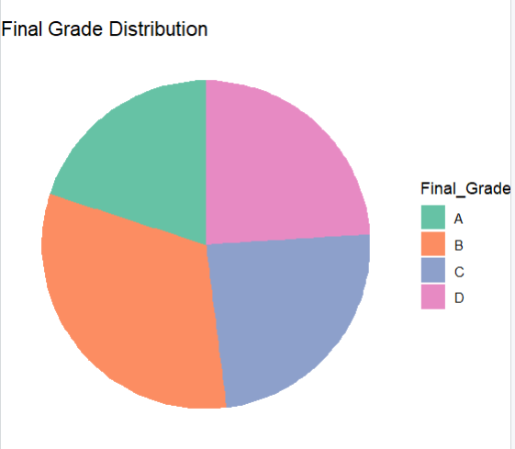

POST-LAB QUESTIONS (PROVIDE BRIEF ANSWERS TO THE FOLLOWING QUESTIONS)
- Which subject shows consistently low performance and why?
Design and Analysis of Algorithms shows consistently low performance compared to other subjects. Its average marks are lower across multiple internal assessments. This indicates that students find the subject conceptually challenging. The complexity of problem-solving may affect understanding. Additional academic support and teaching strategies are required.
- Why is a line chart suitable for trend analysis?
Line charts are ideal for analyzing performance trends over time. They show continuous changes across multiple assessments clearly. Improvement or decline in marks can be easily observed. Patterns and fluctuations become visually apparent. This makes line charts effective for academic trend analysis.
- What limitations does a pie chart have in analytics?
Pie charts are not suitable for comparing small differences between categories. They become confusing when the number of categories increases. Exact values are difficult to interpret visually. They do not show trends over time. Hence, pie charts have limited analytical usefulness.
- How can this analysis help curriculum planning?
Performance analysis helps identify subjects that need curriculum improvement. Faculty can redesign lesson plans based on student difficulties. Teaching hours and assessment methods can be adjusted. Weak areas can be addressed systematically. This results in improved curriculum effectiveness.
- How can such visualizations be integrated into AI-driven academic analytics?
Visualized academic data can be used as input for AI and machine learning models. AI systems can predict student performance and risk levels. Dashboards can display real-time analytics and alerts. Automated insights support academic planning. This enables intelligent, data-driven educational management.

ASSESSMENT
Description | Max Marks | Marks Awarded
Pre Lab Exercise | 5
In Lab Exercise | 10
Post Lab Exercise | 5
Viva | 10
Total | 30
Faculty Signature

